FakeSMTP
# Source: AI Source: Provided by: [Data Path: Persons Table -> ID Column: 1, Name_En Column: Motasem Essam] -> From: [Chatgpt (GPT‑5 Mini)] on [1/21/2026]
FakeSMTP is a Java-based fake email server — like MailHog — that lets developers test sending emails from their applications without actually delivering them to real recipients.

📦 What Is FakeSMTP?
# Source: AI Source: Provided by: [Data Path: Persons Table -> ID Column: 1, Name_En Column: Motasem Essam] -> From: [Chatgpt (GPT‑5 Mini)] on [1/21/2026]
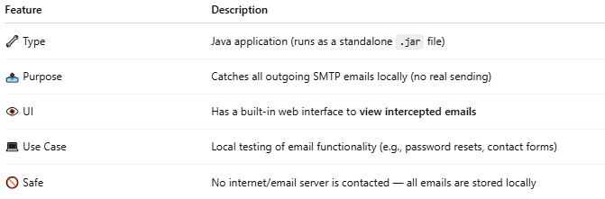
Feature | Description
🔧 Type | Java application (runs as a standalone .jar file)
📤 Purpose | Catches all outgoing SMTP emails locally (no real sending)
👁 UI | Has a built-in web interface to view intercepted emails
💻 Use Case | Local testing of email functionality (e.g., password resets, contact forms)
🚫 Safe | No internet/email server is contacted — all emails are stored locally

✅ Main Use Cases
# Source: AI Source: Provided by: [Data Path: Persons Table -> ID Column: 1, Name_En Column: Motasem Essam] -> From: [Chatgpt (GPT‑5 Mini)] on [1/21/2026]
- Testing mail() or SMTP email without sending real messages
- Capturing emails during app development
- Debugging headers, formatting, and SMTP setup

🛠 How It Works
# Source: AI Source: Provided by: [Data Path: Persons Table -> ID Column: 1, Name_En Column: Motasem Essam] -> From: [Chatgpt (GPT‑5 Mini)] on [1/21/2026]
- Download the FakeSMTP .jar file
- Run it:
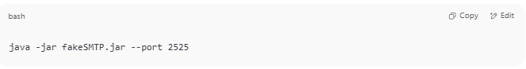
java -jar fakeSMTP.jar --port 2525

- It starts listening on port 2525
- Configure your app (PHP, Python, etc.) to send emails to:
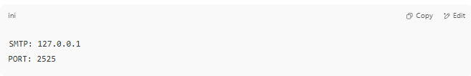
SMTP: 127.0.0.1
PORT: 2525

- Open the FakeSMTP UI in a browser (usually auto-opens), and you’ll see the emails

🔄 FakeSMTP vs MailHog
# Source: AI Source: Provided by: [Data Path: Persons Table -> ID Column: 1, Name_En Column: Motasem Essam] -> From: [Chatgpt (GPT‑5 Mini)] on [1/21/2026]
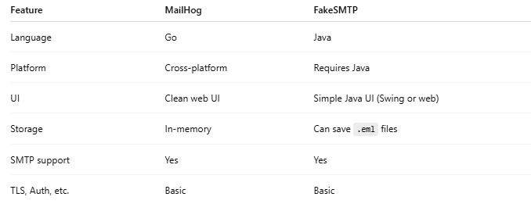

Feature | MailHog | FakeSMTP
Language | Go | Java
Platform | Cross-platform | Requires Java
UI | Clean web UI | Simple Java UI (Swing or web)
Storage | In-memory | Can save .eml files
SMTP support | Yes | Yes
TLS, Auth, etc. | Basic | Basic

✅ Summary
# Source: AI Source: Provided by: [Data Path: Persons Table -> ID Column: 1, Name_En Column: Motasem Essam] -> From: [Chatgpt (GPT‑5 Mini)] on [1/21/2026]
FakeSMTP is a lightweight, Java-based fake SMTP server for safely catching emails during development. It’s great for testing, works offline, and is similar to MailHog — but in Java.

Download FakeSMTP
# Source: ScreenShots Source: Provided by: [Persons Table -> ID Column: 1, Name_En Column: Motasem Essam] -> Tool: [Lightshot Program] -> From [Site: Google Search: All: FakeSMTP] on [1/21/2026]
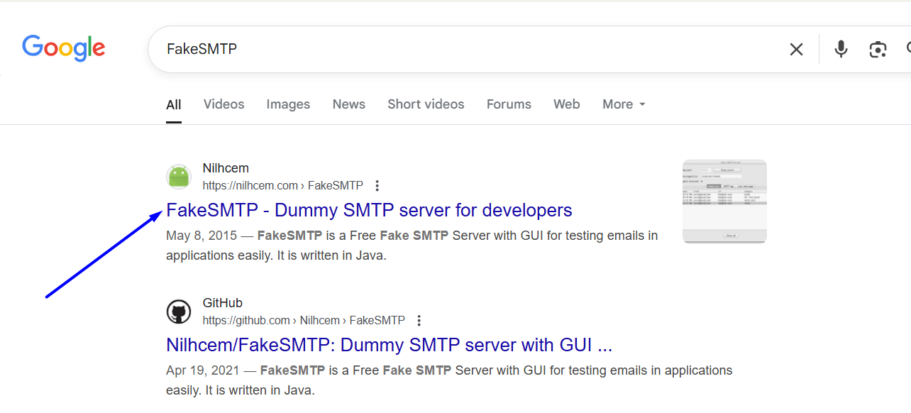

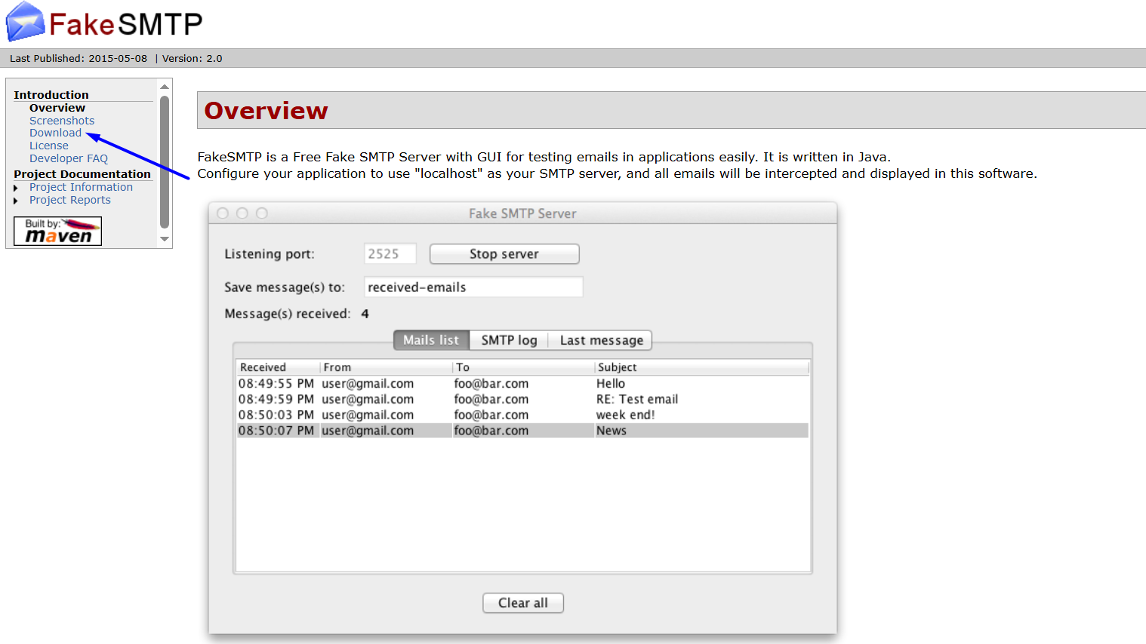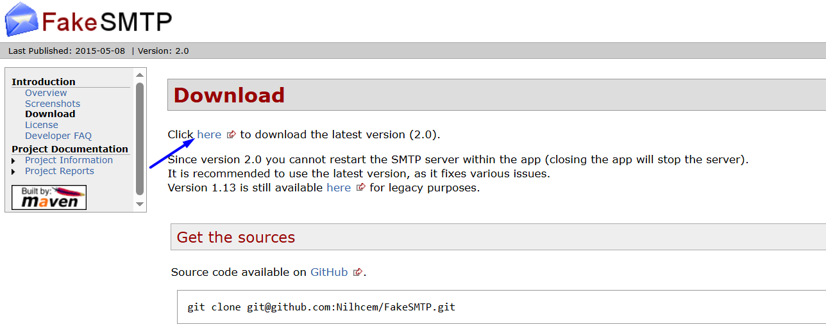

Install FakeSMTP
# Source: ScreenShots Source: Provided by: [Persons Table -> ID Column: 1, Name_En Column: Motasem Essam] -> Tool: [Lightshot Program] -> From [Operating system: Windows: Windows 10: fakeSMTP-latest.zip] on [1/21/2026]
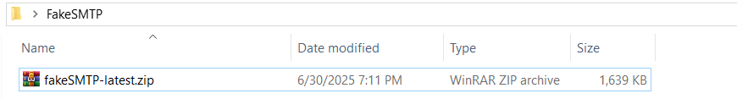
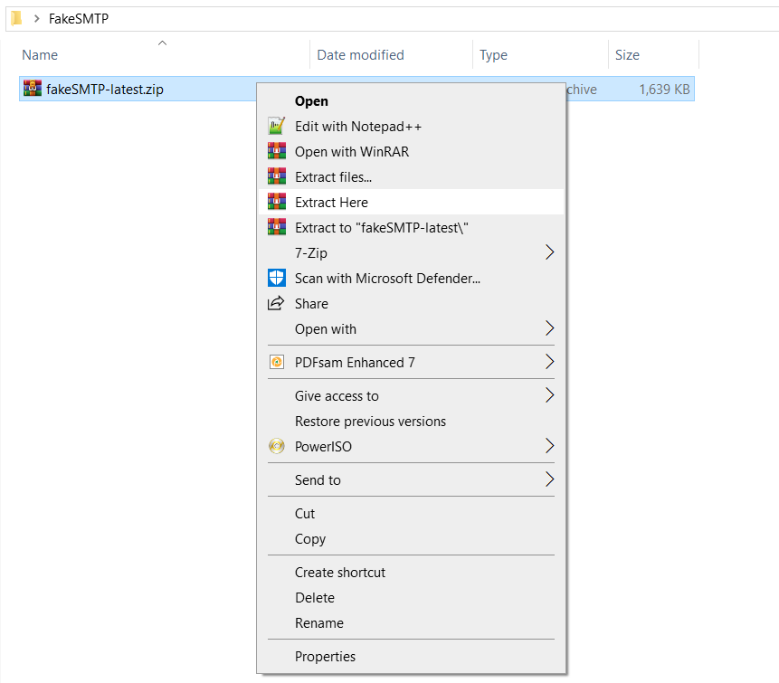
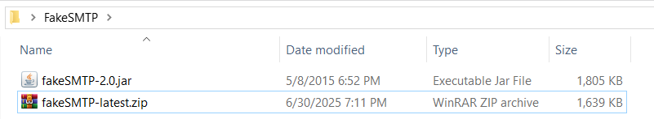
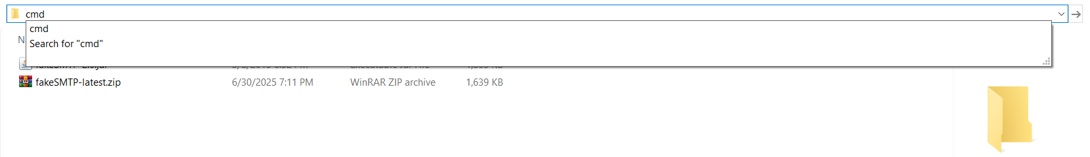
cmd
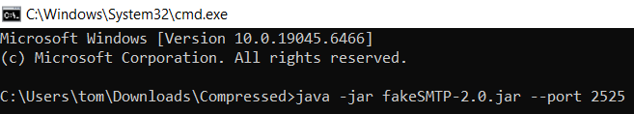
java -jar fakeSMTP-2.0.jar --port 2525
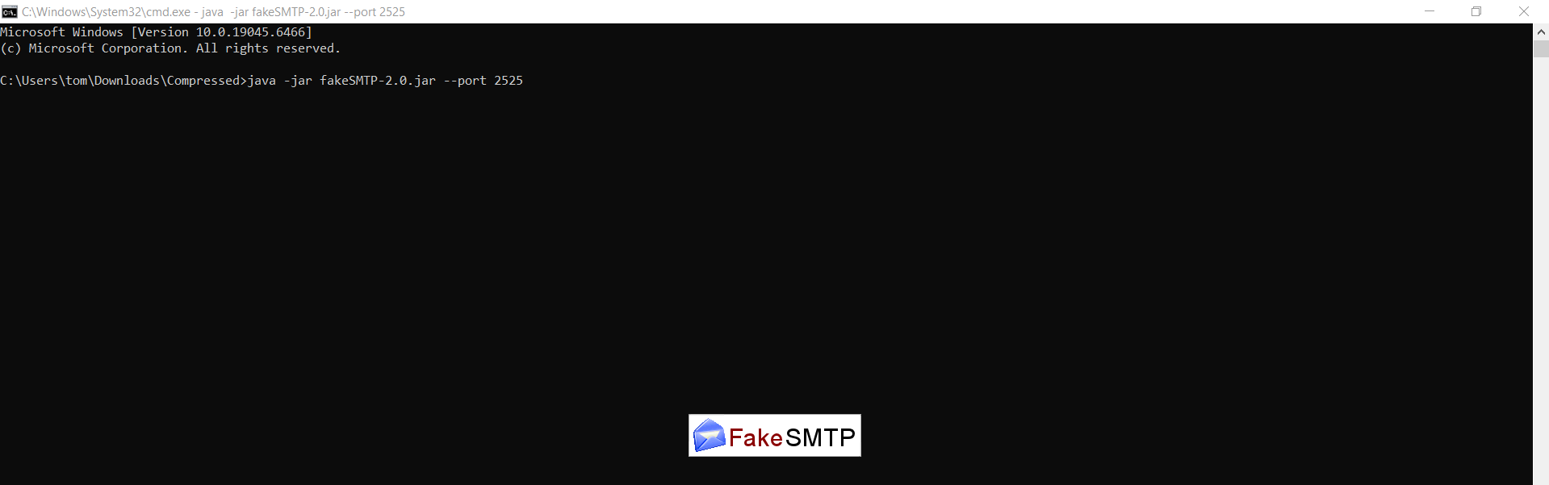

Run FakeSMTP
# Source: ScreenShots Source: Provided by: [Persons Table -> ID Column: 1, Name_En Column: Motasem Essam] -> Tool: [Lightshot Program] -> From [Operating system: Windows: Windows 10: Fake SMTP Server] on [1/21/2026]
